An Analysis of Relationship between U.S. Dollar Index and Real Gold Price
Zirui Huang, October 2025
- Introduction
Gold, a kind of charming metal, plays a very significant role in human society and people appreciate its shining color and precious value. In ancient times, the corpses of kings and queens were buried with gold; In modern times, even ordinary public can purchase gold as an investment while governments purchase gold as their foreign exchange reserve.
From recent press, real gold price (Abbreviated as gold price) has risen vigorously from October 2024 to now [1], with around 2,500 U.S. dollars per ounce in October 2024 and about 4,000 U.S. dollars per ounce in October 2025, supported by the data shown in figure 1.1.

Figure 1.1 The Line Graph of Gold Price XAU/USD between October 2024 and October 2025. Source: http://www.investing.com/currencies/xau-usd-historical-data
Meanwhile, there has been a plummet in terms of U.S. dollar index (Abbreviated as ‘DXY’ generally) throughout the same period, particularly in the Q1 of 2025, as shown in Figure 1.2.

Figure 1.2 The Line Graph of U.S. Dollar Index between October 2024 and October 2025. Source: https://www.investing.com/currencies/us-dollar-index-historical-data
Here, we use the percentage change method to indicate the relative change of these two sets of data (choosing base date as 10/14/2024):
$Relative Percentage Change in Gold Price= \frac{Current Price - Price of Base Date}{Price of Base Date }$ $×100\%$
$Relative Percentage Change in U.S. Dollar Index = \frac{Current Index - Index of Base Date}{Index of Base Date} ×100\%$
Then the transformed data are plotted together on a new line graph, demonstrating the difference in the trend of two kinds of data, as demonstrated in Figure 1.3.
It is spotted that an overall rough negative correlation was shown in the given period. With this superficial estimation, it elicits some problems: was the correlation between DXY and gold prices always negative? What is the relationship between these two variables? What were the explicit and subtle reasons for the fluctuations? To respond to these questions, the following content will give the answer.

Figure 1.3 A Comparison Graph Between U.S. Dollar Index and Gold Price in Percentage Change.
The structure of this piece of research will be organized as follows: the quantitative methods developed by the previous studies will be mentioned as literature review, and then some approaches will be picked as the methodology of this report. With the experimental results obtained from the data analysis, a qualitative explanation will be given in the discussion part to support the quantitative analysis, combining the impulses from historical events, macroeconomic policies, behavioral economics and so on.

- Literature Review and Methodology
It is biased to take a glance at the plotted graph and then allege that two variables have certain relationships: a rigorous quantitative method is required to measure the relationship using unbiased numbers.
From previous researchers, it is effective to propose a hypothesis from observation of graph and then use quantitative methods to verify or reject the hypothesis, which is known as hypothesis testing in terms of statistics [2]. For what statistical model to apply, numerous methods were applied by previous study, ranging from simple models, like Pearson’s correlation coefficient, to relatively advanced models, like Vector Error Correlation Model (VECM), observed by Lin et al [3].
And many researchers explored the correlation by considering long-term effect and short-term impact, which can give a comprehensive comparison. The piece of research focusing on the dynamic linkages among the gold market, US dollar and crude oil market contributed by Mo B et al, offers a legitimate approach that applying fractional cointegration and DCC-MGARCH method for time-varying long-term analysis (1990-2016) and exerted Krystou-Labys non-linear asymmetric Granger causality method for the analysis after the 2008 financial crisis (2007-2016) for analyzing the strike of financial crisis in the short run [4]. Additionally, He et al used threshold VECM to specifically study the dynamic of gold and the dollar, with different time intervals for rolling windows varying from 3 months to 10 years embedded in period January 1976 to December 2017, deriving a growing negative correlation as the time span increases [5].
Moreover, and importantly, a large number of models are merely suitable for particular scenarios rather than for general use. For instance, standard GARCH models are prone to overrating the potential volatility persistence when a break is not allowed in the long time series [6]. Another example is that linear regression analysis after taking logarithms is used for the relationship between U.S dollars, stock, crude oil and gold in the research paper of Khalife et al, which are suitable for long-term analysis compared to short-term analysis for the reason that long period exhibits lower volatility [7].
Considering the utility of models, this report will employ two different methods to look into the relationship between DXY and gold price. For short-term analysis, consistent with standard practice in financial econometrics, we will consider the level and differenced data, which are commonly assumed to be non-stationary and stationary respectively and to confirm this, Augmented Dickey-Fuller (ADF) Test will be conducted [8]. Then, a rolling Pearson correlation coefficient method will be used for modeling the relationship of two lines of data, which alleviates the effect of outliers and possesses the ability to measure non-linear dependence compared to the traditional method of Pearson correlation coefficient [9]. On the other hand, the level and differenced data will be examined again on the basis of ADF to guarantee that the data are integrated of order one as the commonsense and then Vector Error Correction Model (VECM) or Vector Autoregression model (VAR) will be applied depending on the results of ADF to seek whether the relationship derived by the rolling Pearson correlation changes in a dynamic and long-term outlook [10].
- Data & Parameter Selection
All data are daily closing price data and sourced from the commonly authorized database website ‘investing’, with the data from 1985 to 2025 extracted. The reason why the data before 1985 are not used is that when coming before 1985, the worldwide financial system was more drastic since it was just divorced from The Bretton Woods System, and it experienced a transitional period for reconstruction and reinforcement. And the analysis is divided into three time intervals, 1985-2007, 2008-2019, 2020-2025, due to 2008 Financial Crisis and 2020 COVID-19 pandemic, and this is supported by the conclusion given by Miyazaki and Hamori [11], that under different macroeconomic environments and policies, the reflected relationship is very likely to change significantly, and therefore this separation can make it easier for subsequent qualitative explanation.
In terms of the choice of window length of rolling Pearson correlation coefficient method, in periods of rising market uncertainty, shorter windows are also considered to better capture rapid structural changes and vice versa. A main window is chosen due to the economic characteristics whereas robustness checks using auxiliary window lengths as comparison yield qualitatively similar results. Detailed parameters are arranged here: 60 trading days as the main window length while 30 and 120 trading days as auxiliary window length.
While the rolling correlation analysis incorporates the choice of window length as a time-scale parameter, the VECM or VAR requires a set of specifications, including the sample period, cointegration rank, lag order, and deterministic components, each of which reflects underlying economic assumptions and relies on the pre-experimental tests. Also, depending on unit root test results, either VECM or VAR will be employed. The parameter selection of this part will be specified in the next section. More specifically, if two variables are non-stationary I(0), VECM will be applied; if one variable is non-stationary I(0) and the other variable is stationary I(1), VAR is applied; if both variables are stationary I(1), the model will be re-considered.

- Quantitative Results
  - Preliminary Analysis
Firstly, the basic properties of the sample data are examined to avoid basic technical errors, shown in Figure 4.1.1 and an overall graph illustrates the trend of two variables, shown in Figure 4.1.2 and Figure 4.1.3.
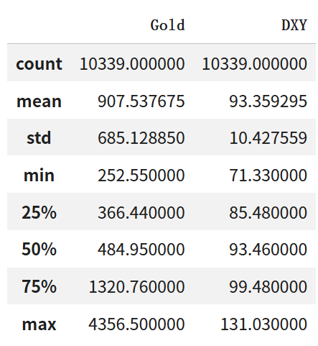
Figure 4.1.1 Descriptive Properties in Sample data
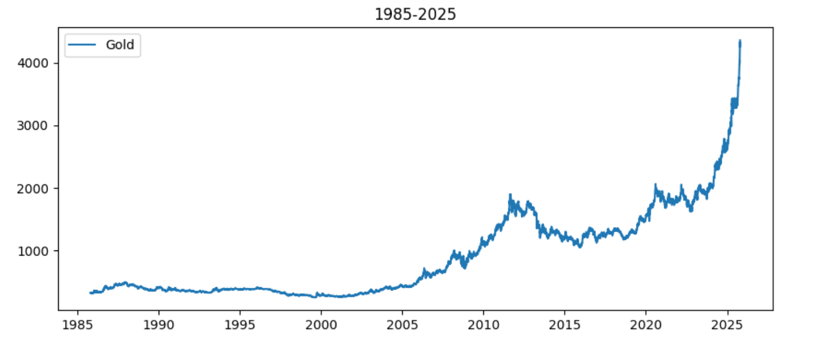
Figure 4.1.2 Line Graph of Gold Price during 1985-2025
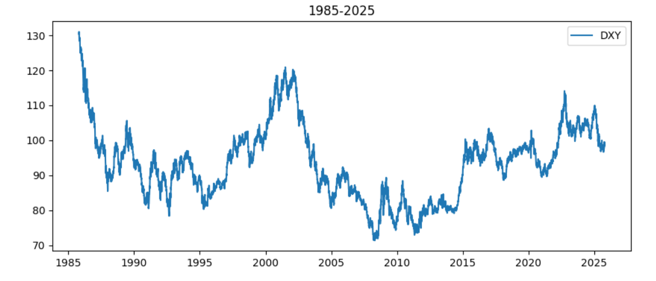
Figure 4.1.3 Line Graph of DXY during 1985-2025

The dataset consists of 10,339 daily observations for both gold price and DXY, aligning each gold price data to each DXY data at the same date.
Gold price demonstrates great volatility, with a mean of 907.54 and a standard deviation of 685.13. Additionally, its mean and medium differ notably, suggesting that this is a positively skewed distribution, agreeing with the overall strong upward trend.
By contrast, DXY index gives lower variability, with a mean of 93.36 and a standard deviation of 10.43. Besides, the relatively lower interquartile range indicates relatively greater stability.
And the corresponding kurtosis replies to these properties, exhibited in Figure 4.1.4, that the kurtosis of 1.50 in the data of gold price reflects a fat-tailed distribution, leading to the higher likelihood of extreme price movements while the kurtosis of 0.06 in the data of DXY reflects a distribution close to normal distribution, suggesting comparatively fewer extreme variations.
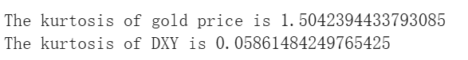
Figure 4.1.4 Results showing the kurtosis of two datasets

  - Augmented Dickey–Fuller (ADF) Test
The Augmented Dickey–Fuller (ADF) test is used to assess the presence of unit roots in both variables and the null hypothesis is that the series has a unit root.
To ensure the robustness, 3 categories of tests are conducted: the test without constant (“n”), with constant (“c”) and with constant and linear trend (“ct”).
The results are displayed in Figure 4.2.1.

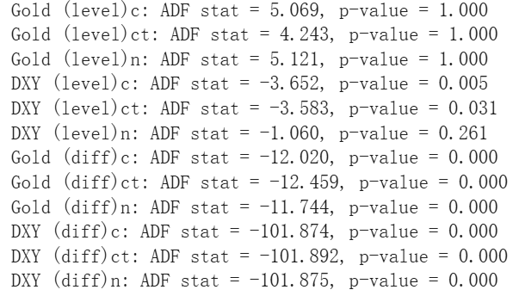
Figure 4.2.1 Results of ADF tests
For gold price in levels, the ADF statistics are insignificant across all specifications (p-values = 1.000), indicating failure to reject the null hypothesis of a unit root. However, the first-differenced series strongly rejects the null hypothesis at the 1% level. Therefore, gold prices are concluded to be integrated of order one, I(1).
Focusing back to DXY, the null hypothesis is rejected as the specification without the constant is not economically meaningful, so it is considered ineffective whereas the specifications with a constant (and linear trend) are rejected at 5% significance level. In other words, the level series is stationary or weakly trend stationary so we consider it as I(0). And the first-differenced series is stationary as expected.
The stationarities of these series are strongly aligned with the basic statistical properties in section 4.1.
Rolling Pearson correlation is employed to explore the time-varying linear association between gold prices and DXY. Meanwhile, the method does not require strict stationarity, results based on level data are interpreted with caution due to potential persistence in the gold price series.
And VAR is chosen instead of VECM as argued in section 3.

  - Rolling Pearson Correlation
The results generated by coding are displayed in Figure 4.3.1.

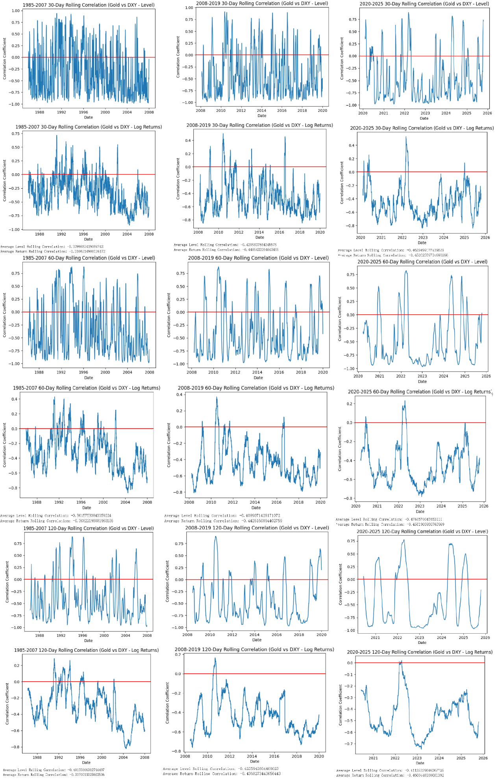
Figure 4.3.1 Results of Rolling Pearson Correlation
Looking at the mean values, they are all negative, verifying a relatively weak negative correlation between gold price and DXY index.
Then, focusing on the graphs, it is spotted that in all the graphs of level data, their figures fluctuate very violently between the positive part and the negative part, despite the phenomenon that in the same time span, as the length of the window shrinks, the figure alters more sharply. Moreover, these findings epitomize the previous ADF test results that the level data of gold price is non-stationary (integrated of order 1).
By contrast, for the figure of data after taking logarithmic return, the rolling Pearson correlation coefficient varies more smoothly. Analogously, if fixing the time span, when the window length increases, the variation is less significant, with positive values appearing less frequently. However, while fixing the window length, the coefficients show similar patterns of great soars and plummets across different time spans in the level data, the figures for logarithmic return reflect greater variation during 1985-2007, medium level of variation during 2008-2019 and steadier variation during 2020-2025, with positive values appearing in a descending frequency order. In other words, in terms of short-run relationships, as the time length for observation increases, the negative correlation between gold price and DXY becomes more stable and, as the time move forward, the negative correlation bond between them becomes tighter.

4.4 Vector Autoregression Model (VAR)
To examine the dynamic interactions between gold returns and DXY returns, a VAR model is estimated using stationary return series. The optimal lag length is selected based on the Akaike Information Criterion (AIC), resulting in a lag order of $p=[X]$. We apply the series of 1985-2007, 2008-2019, 2020-2025 and a newly added time range 1985-2025 as the full sample overview. Numerical results are shown in Figure 4.4.1.

4.4.1 Granger Causality Test
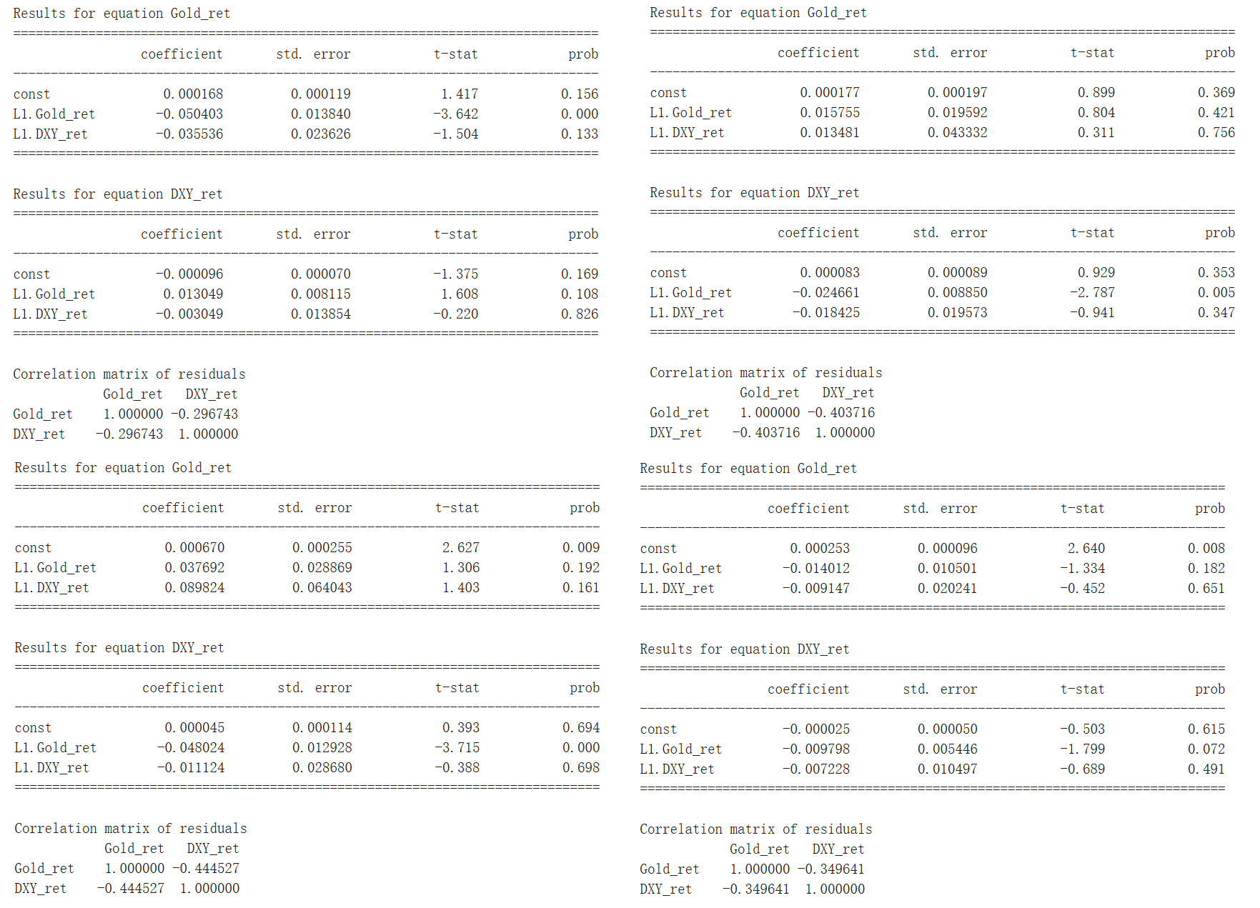
Figure 4.4.1 Numerical Results for the Granger Causality Test, 1985-2007 on the top left, 2008-2019 on the top right, 2020-2025 on the bottom left, 1985-2025 on the bottom right
Focusing on 1985-2007, applying 5% significance level (same for the following), it is found that the gold equation is significant on the lag term for gold, indicating a short-term reversion of gold price. Conversely, all the lag terms in the DXY equation are not significant. Combining the two equations, there is almost no predictive spillover between the gold price returns and DXY returns.
During the post-financial period 2008-2019, it is observed that although the DXY returns do not Granger-cause the gold price returns, the gold returns do Granger-cause the DXY price returns, manifesting the unidirectional and negative-correlation predictive spillover.
Likewise, in the post-COVID era 2020-2025, the causality results demonstrate the same but stronger negative signal of more negative coefficient from gold price returns to DXY returns with all other insignificant signals presented as noises: The reliability using the gold price returns to predict DXY returns is strengthened.
From an overall perspective, throughout 1985-2025, all the lag terms are not significant in the gold equation and the DXY equation, suggesting that the long-term predictive relationship between gold and DXY is weak.
Moreover, the correlation coefficient in residuals becomes more negative from -0.297 to -0.445, indicating that the bond between gold price and DXY had been tightened.
4.4.2 Impulse Response Function (IRF) Analysis
To further dig into the dynamic connection between the two targeted variables, orthogonalized Impulse Response Functions (IRFs) are computed using Cholesky decomposition, displayed in Figure 4.4.2.
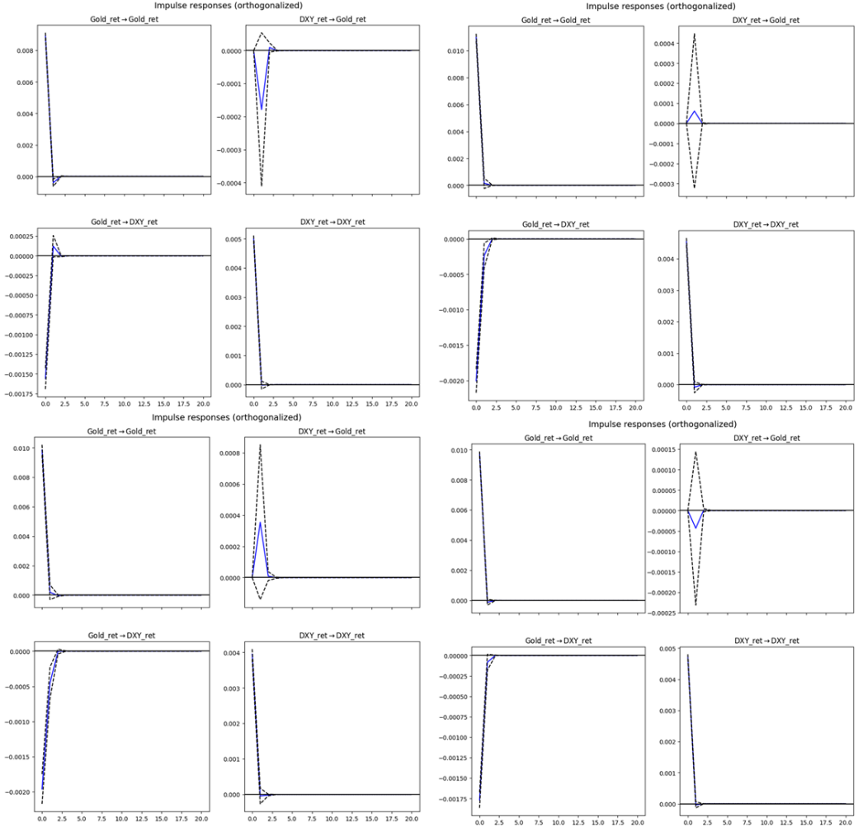
Figure 4.4.2 Graphic Results for the IRFs for VAR model, 1985-2007 on the top left, 2008-2019 on the top right, 2020-2025 on the bottom left, 1985-2025 on the bottom right
Across all the subsamples and the full sample and with a 95% confidence interval (dashed lines), impacts on DXY generate an insignificant response in gold price, but the magnitude of the responses are small and dissipate within roughly 1-2 trading days. Similarly, the response of DXY to gold shocks is economically small and statistically insignificant across subsamples, suggesting limited reverse spillover effects.

- Qualitative Discussion
In empirical analysis, it has been demonstrated that there is a generally negative relationship between the gold price and the DXY index, in both rolling Pearson correlation model and Vector autoregression (VAR) model, so that gold can be a hedge against the dollar in most of the periods, agreeing with prior findings from Capie, Mills and Wood [12].
However, the nature of this relationship is not long-term but short-term transmission. From VAR model in first-differenced time series and orthogonalized Impulse Response Function (IRF), it is observed that the short-term spillovers between gold returns and DXY returns are generally insignificant and dissipate rapidly, generally in 1-2 trading days. For the full sample (1985-2025), it is shown that shocks to either variable do not lead to statistically significant responses in the other beyond the very short horizon, with confidence intervals that consistently include zero throughout the forecast window. Therefore, due to the weak predictive relationship in the long run and quick absorptions of shocks by markets, the interaction between gold returns and DXY returns is characterized by time-varying short-run dynamic linkage rather than stable long-run balanced mechanisms, supported by the recent study by Azimli [13]. A subtle reason is that financial markets fully incorporate past price information and adjust quickly to new information, with high-frequency returns often exhibiting minimal persistence, aligning with the weak-form Efficient Market Hypothesis.
Moreover, the absence of full-sample dynamic effects may reflect a structural change in financial system and there is more evidence: from Rolling Pearson correlation, the correlation between gold price returns and DXY returns is gradually fastened model whereas the VAR model shows a more powerful and significant unidirectional transmission from gold returns to DXY returns. This continues the pattern found in early 2010s by Joy [14]. An explanation is that during the turmoil periods (2008 financial crisis and 2020 COVID-19 pandemic), the relationship between gold and U.S. dollar intensifies as investors tend to be risk-loathing and use gold to hedge their portfolios, which is aligned with the paper by Baur and Lucey [15]. Also, the economic downturn caused by decreasing rate of economic expansion that occurs in recent years also undermines investors’ confidence, so they are prone to steer clear of potential risk, leading to more use of gold as an asset for hedging. In addition, the negative correlation becomes more apparent when observing in a long-time span, which can be explained by the reason that the monetary policies and real interest rate dynamics dominate the short-term market noise.

- Conclusion
In summary, this report mainly investigates the relationship between gold price and DXY index by quantitative and qualitative analysis on the daily trading data from 1985 to 2025. From rolling correlation methods and the Vector Autoregression Model (VAR), their results give a persistent but time-varying negative association between the two given assets altogether, with a rising negative bonding in the episodes of growing macroeconomic uncertainty, which witnesses the change in financial structure. Separately, the former model shows that the time-length increase will give a more stable negative correlation between gold returns and DXY returns, while the later model with orthogonalized Impulse Response Function (IRF) manifests that the dynamic spillover from gold price to DXY tends to be short-lived, with responses dissipating within one to two trading days, and it is statistically insignificant in full sample so the negative relation between these two asset is better depicted by contemporaneous adjustment and regime-dependent behavior than by stable long-run transmission mechanisms.

7. References
[1] BBC News. Gold surges past $4,000 an ounce as uncertainty fuels rally [EB/OL]. https://www.bbc.co.uk/news/articles/c8ex3wgjlexo, 2025-10-16.
[2] Zhan, Y. (2024). Research on the Correlation between the Movement of the Dollar and the Price of Gold. Theoretical and Natural Science, 41, 126-131. https://doi.org/10.54254/2753-8818/41/2024CH0167
[3] Lin, F. L., Chen, Y. F. and Yang, S. Y. (2016). Does the value of US dollar matter with the price of oil and gold? A dynamic analysis from time–frequency space. International Review of Economics & Finance, 43, 59-71. https://doi.org/10.1016/j.iref.2015.10.031
[4] Mo, B., Nie, H. and Jiang, Y. (2018). Dynamic linkages among the gold market, US dollar and crude oil market. Physica A: Statistical Mechanics and its Applications, 491, 984-994. https://doi.org/10.1016/j.physa.2017.09.091
[5] He, Q., Guo, Y. and Yu, J. (2020). Nonlinear dynamics of gold and the dollar. The North American Journal of Economics and Finance, 52, 101160. https://doi.org/10.1016/j.najef.2020.101160
[6] Lamoureux, C. G. and Lastrapes, W. D. (1990). Persistence in variance, structural change, and the GARCH model. Journal of Business & Economic Statistics, 8(2), 225-234. https://doi.org/10.1080/07350015.1990.10509794
[7] Khalife, D., Elia, R., El Chaarani, H. and Bou Nader, E. (2022). Intermarket Analysis: Oil, Gold, US Dollar and Stock Market Intermarket Analysis: Oil, Gold, US Dollar and Stock Market. The Arab Economic and Business Journal (AEBJ) (ISSN 2214-4625), Vol. 14 (2022), Iss. 2, Article 7. https://doi.org/10.38039/2214-4625.1021
[8] Centre for Financial and Management Studies, SOAS, University of London. (2023). Unit 1: Statistical properties of financial returns (Course material). SOAS, University of London. https://www.soas.ac.uk/sites/default/files/2023-02/M459_unit-01_sample.pdf
[9] Yang, Y. (2025). The Impact of Interconnectedness Variation of Global Stock Markets for Geopolitical Conflicts. Chaoyang University of Technology. https://ir.lib.cyut.edu.tw/bitstream/310901800/45062/1/113CYUT0304011-002.pdf
[10] P.C.B., Phillips. (1986). Understanding spurious regressions in econometrics, Journal of Econometrics, Volume 33, Issue 3, ISSN 0304-4076, 311-340. https://doi.org/10.1016/0304-4076(86)90001-1
[11] Miyazaki, T., & Hamori, S. (2014). Cointegration with regime shift between gold and financial variables. International Journal of Financial Research, 5(4), 90-97. https://doi.org/10.5430/ijfr.v5n4p90
[12] Capie, F., Mills, T. C., & Wood, G. (2004). Gold as a Hedge against the US Dollar. World Gold Council.
[13] Azimli, A. (2024). Is gold a safe haven for the US dollar during extreme conditions?. International Economics, 177, 100478. https://doi.org/10.1016/j.inteco.2024.100478
[14] Joy, M. (2011). Gold and the US dollar: Hedge or haven?. Finance Research Letters, 8(3), 120-131. https://doi.org/10.1016/j.frl.2011.01.001
[15] Baur, D. G., & Lucey, B. M. (2010). Is gold a hedge or a safe haven? An analysis of stocks, bonds and gold. Financial review, 45(2), 217-229. https://doi.org/10.1111/j.1540-6288.2010.00244.x

